**Car Price Prediction on Formerly owned vehicle using Machine Learning Model.**

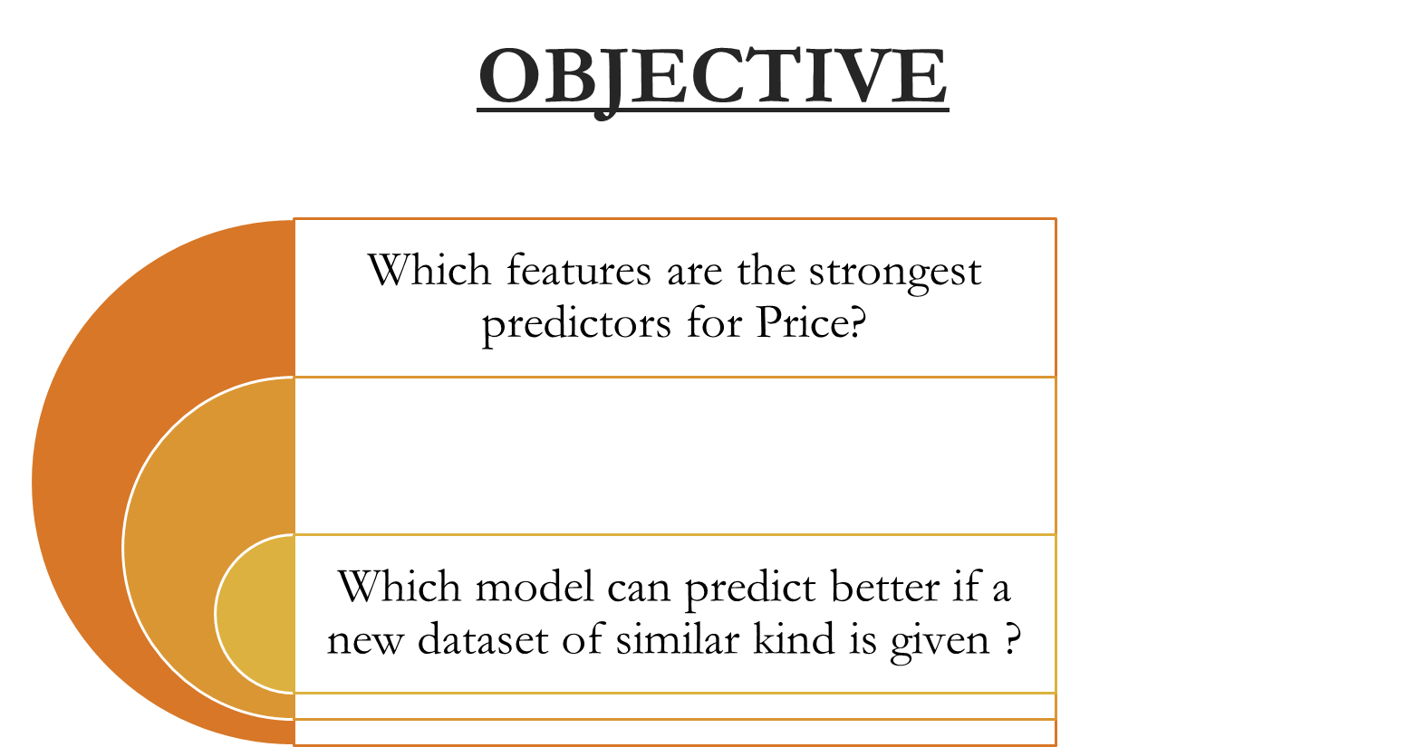

**Target Variable:**

•Selling Price

**Predictor Variables:**

•Car Name

•Year

•Kms_Driven

•Fuel_Type

•Seller_Type

•Transmission

•Owner

•Day Mins

•Day Calls

•Monthly Charge

•Overage Fee

•Roam Mins

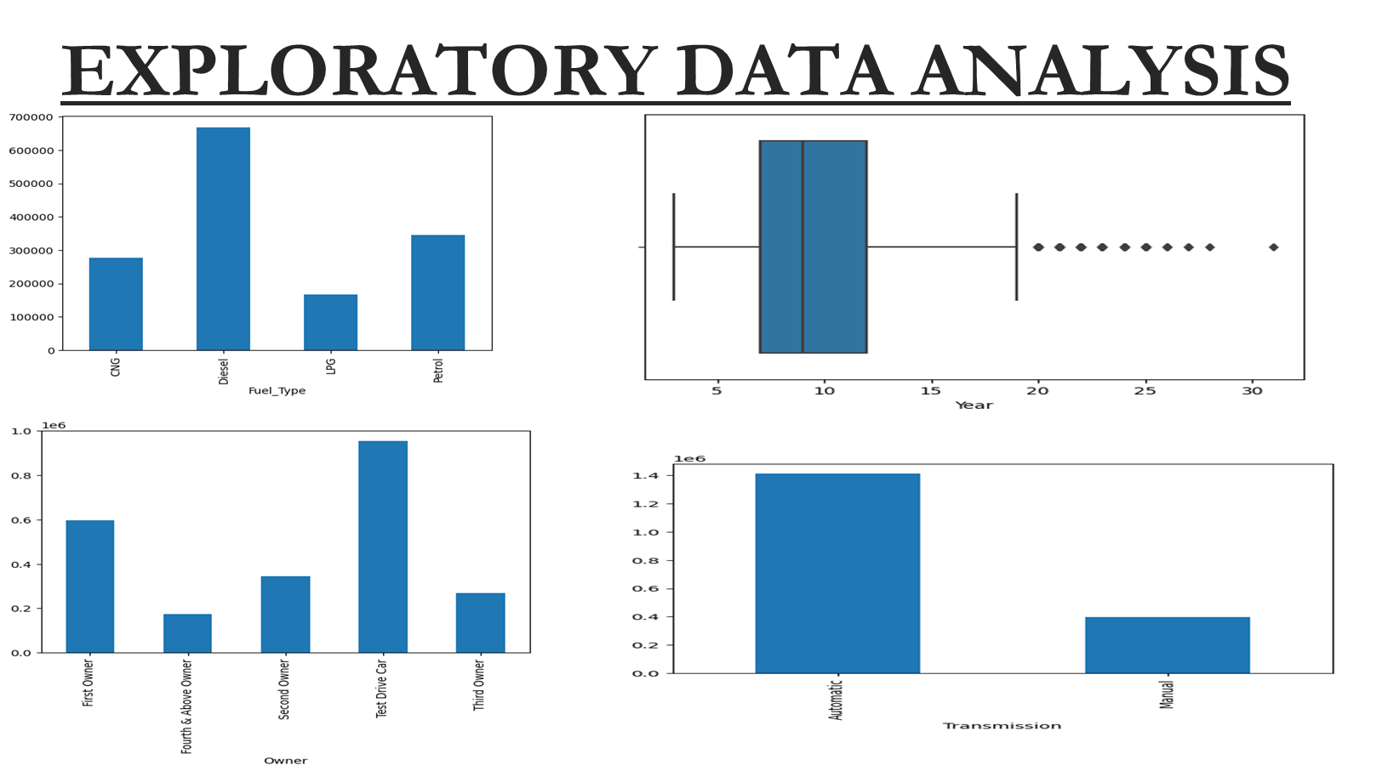

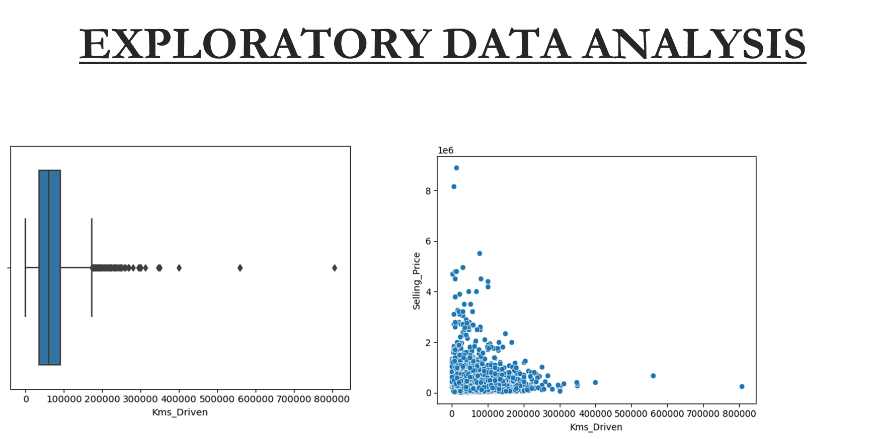

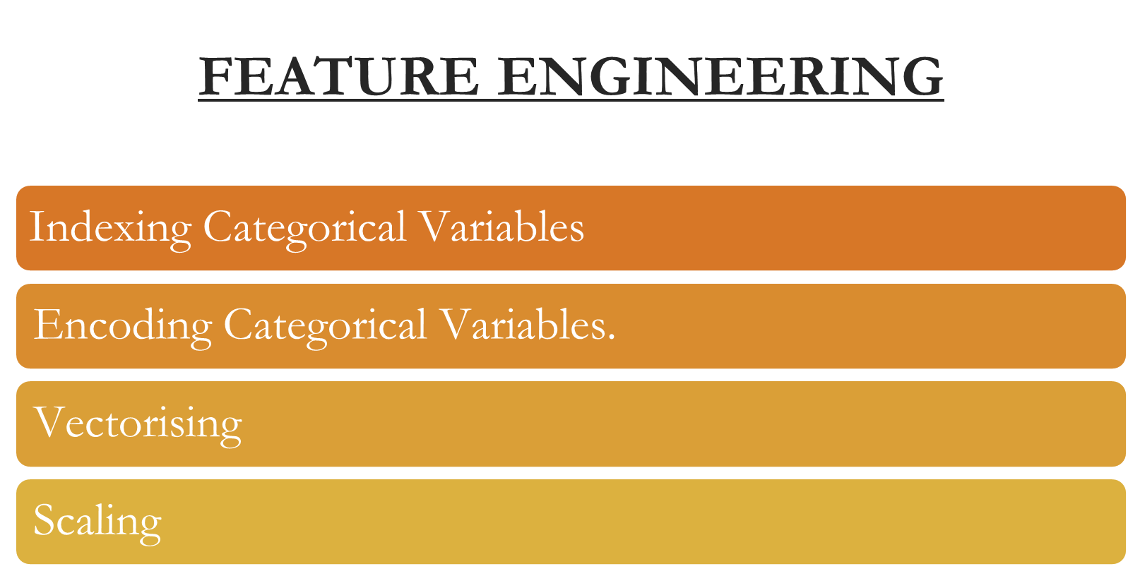

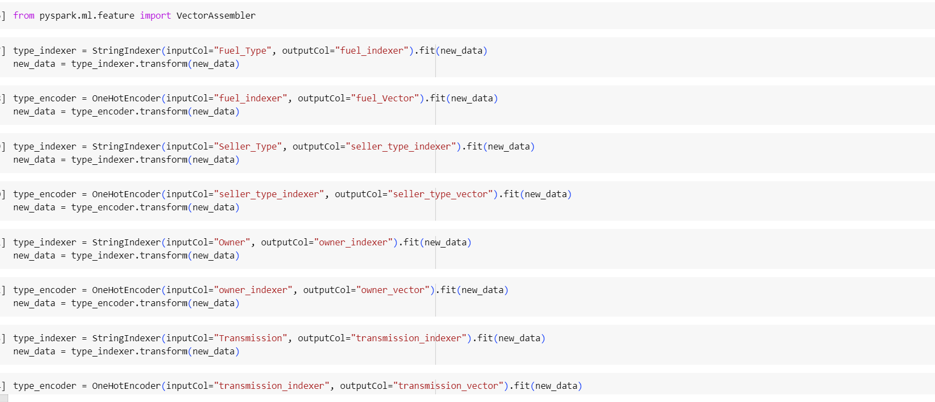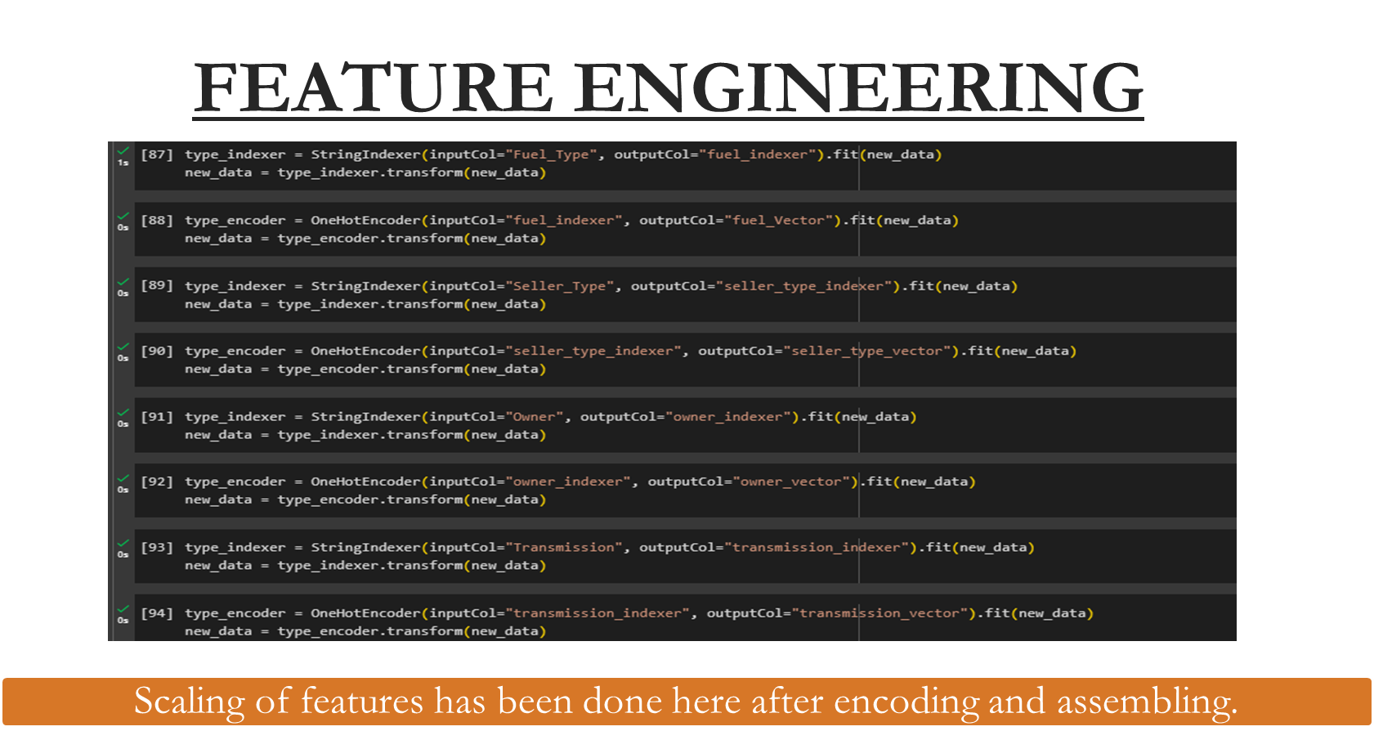

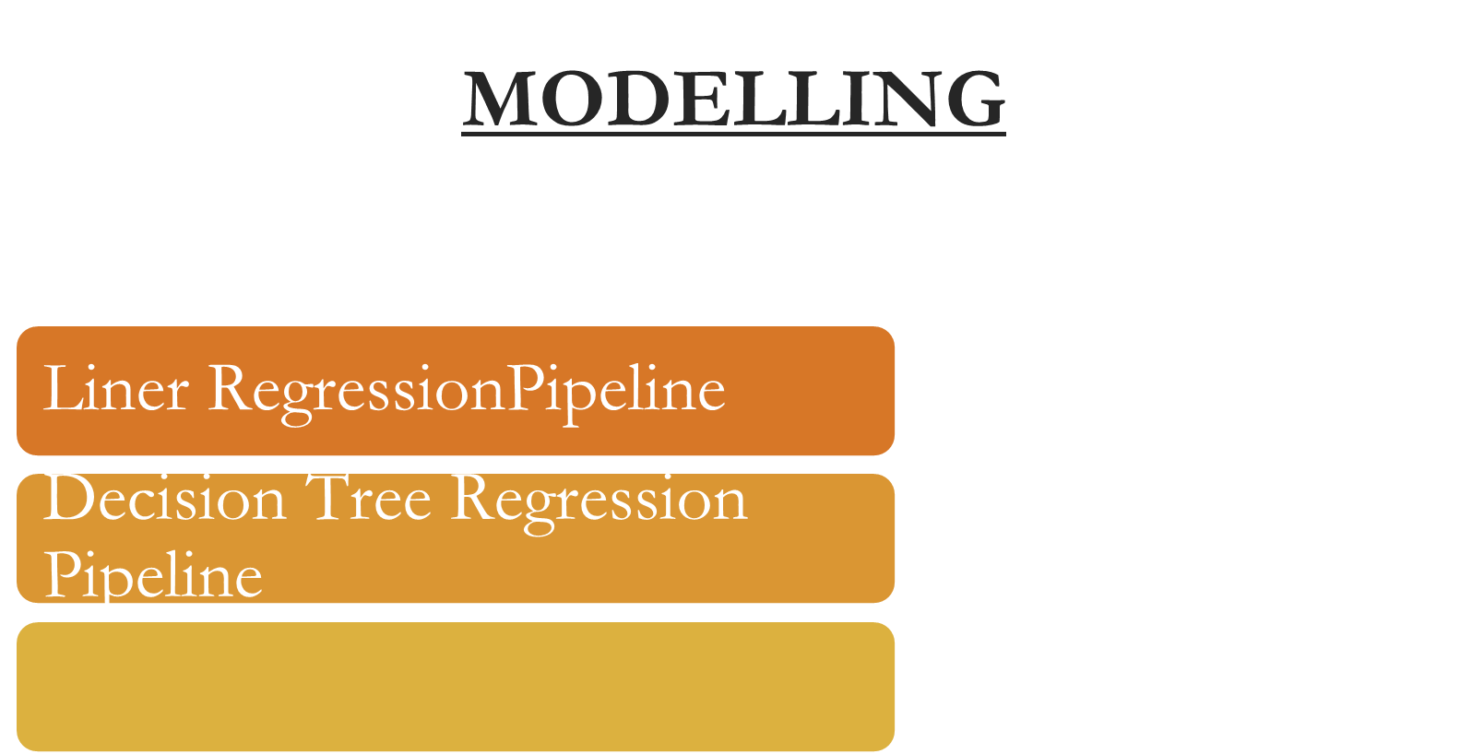

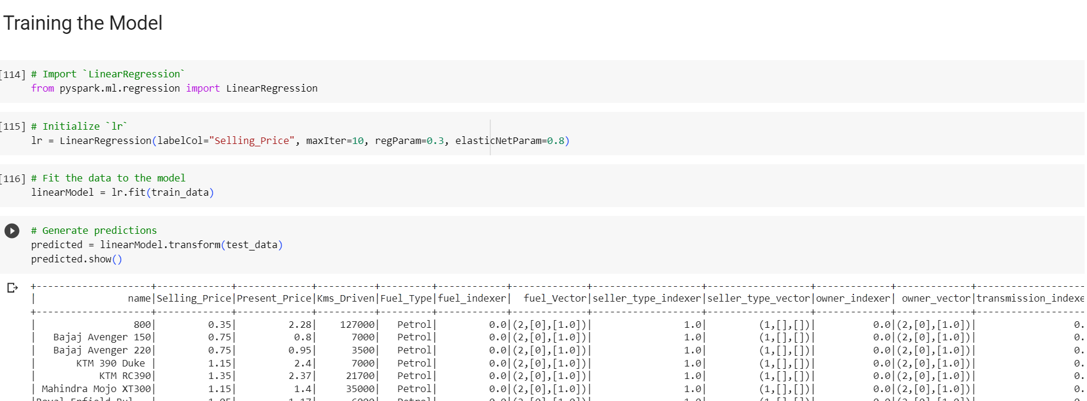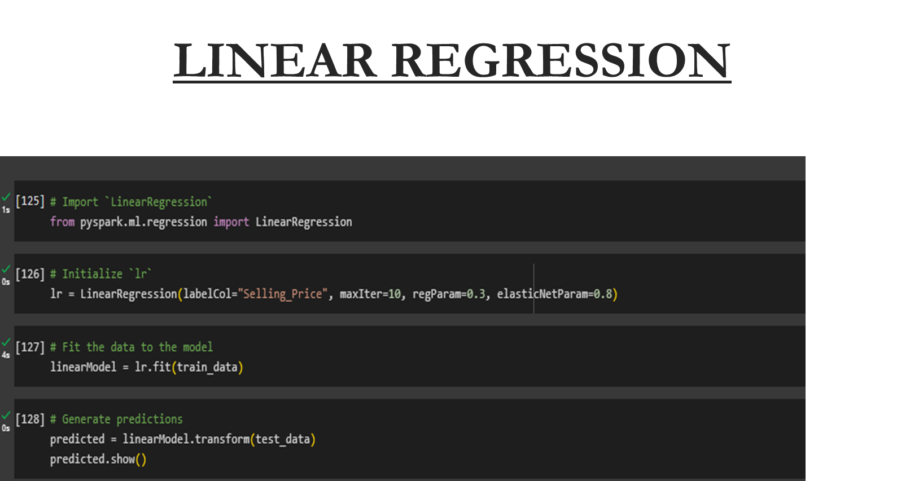

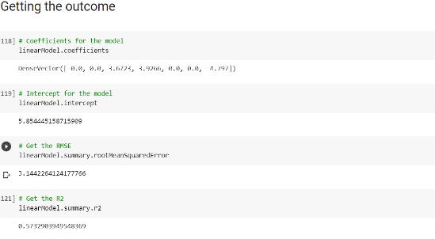

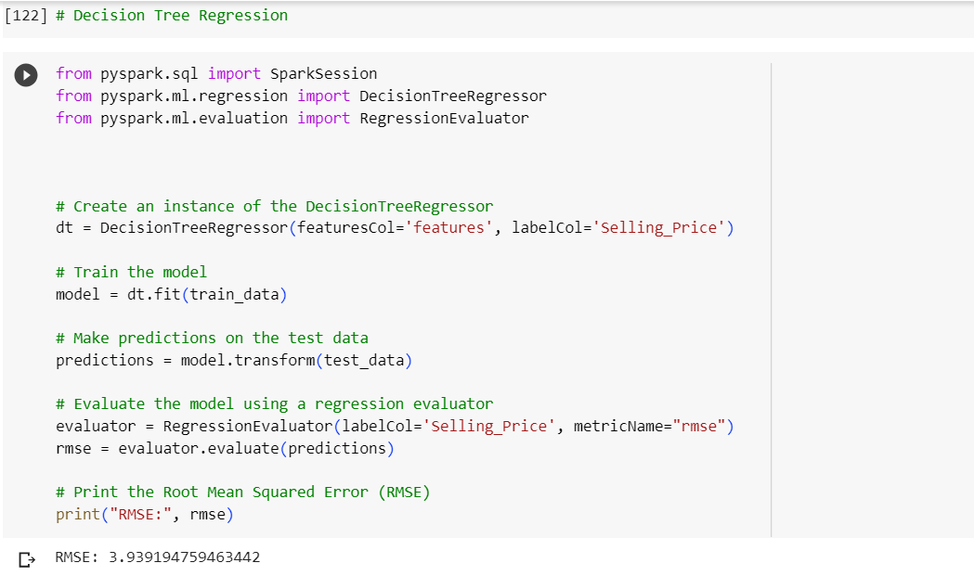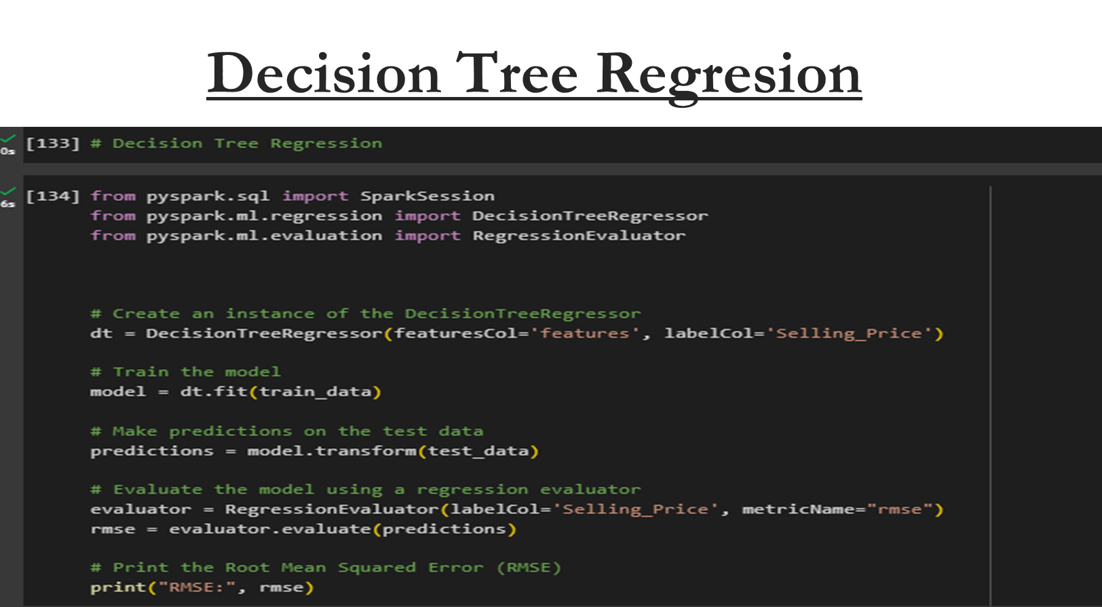

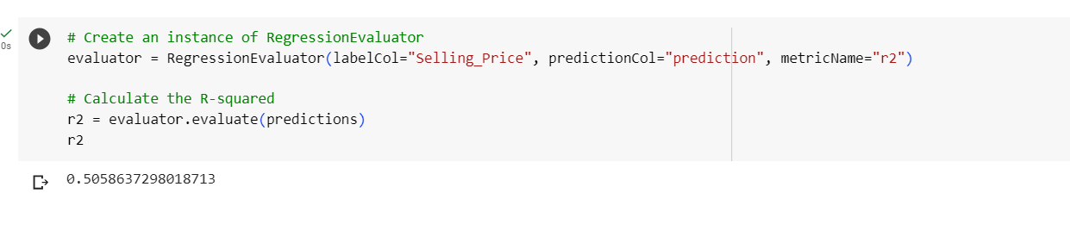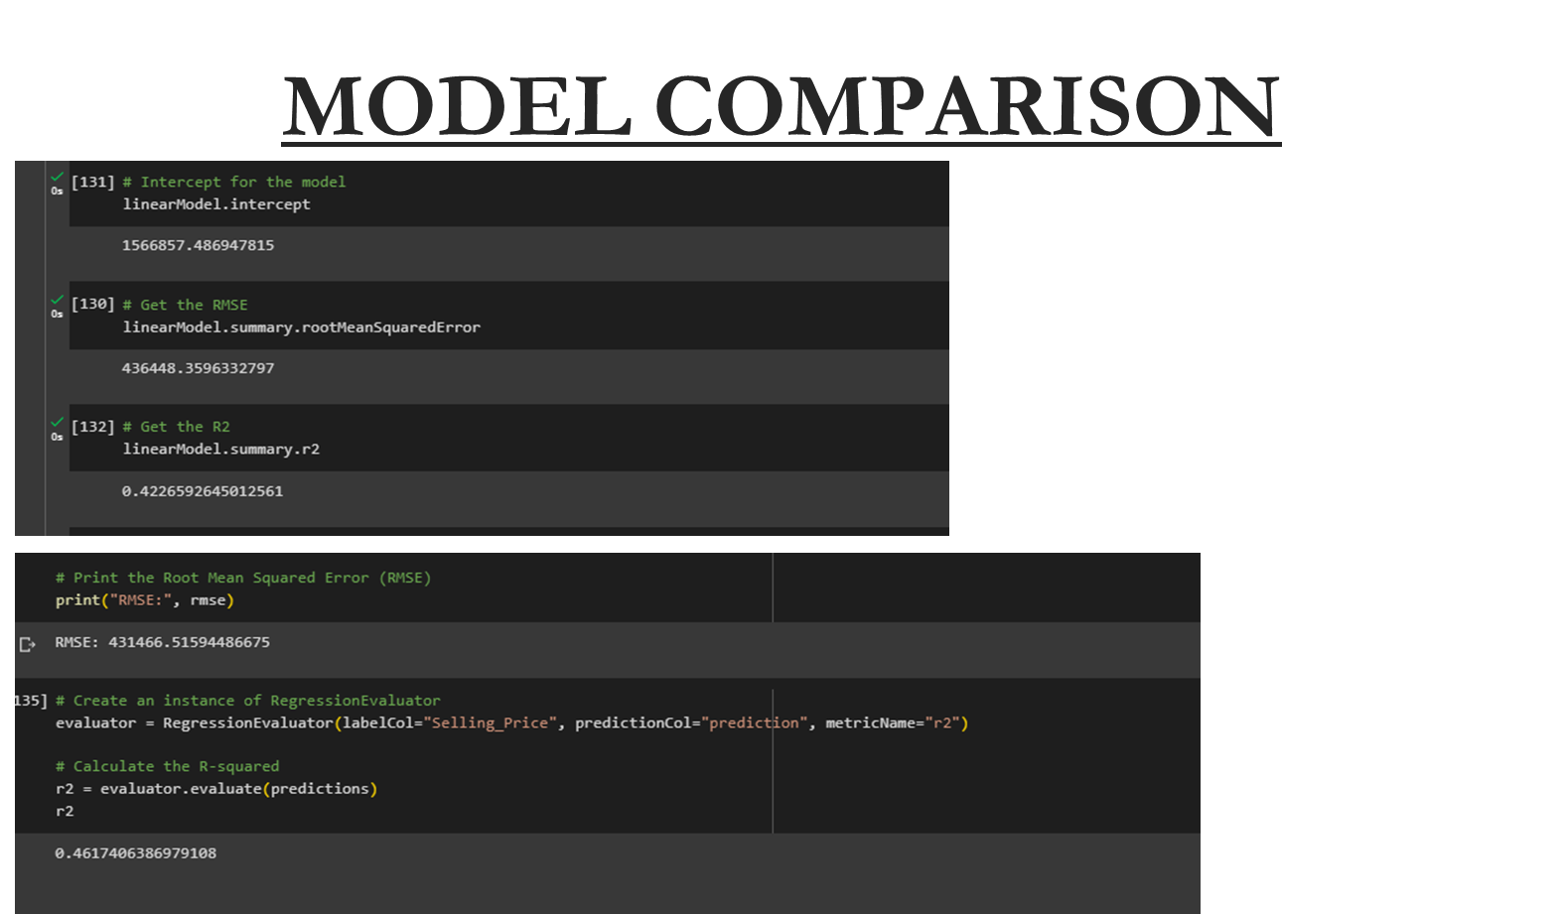

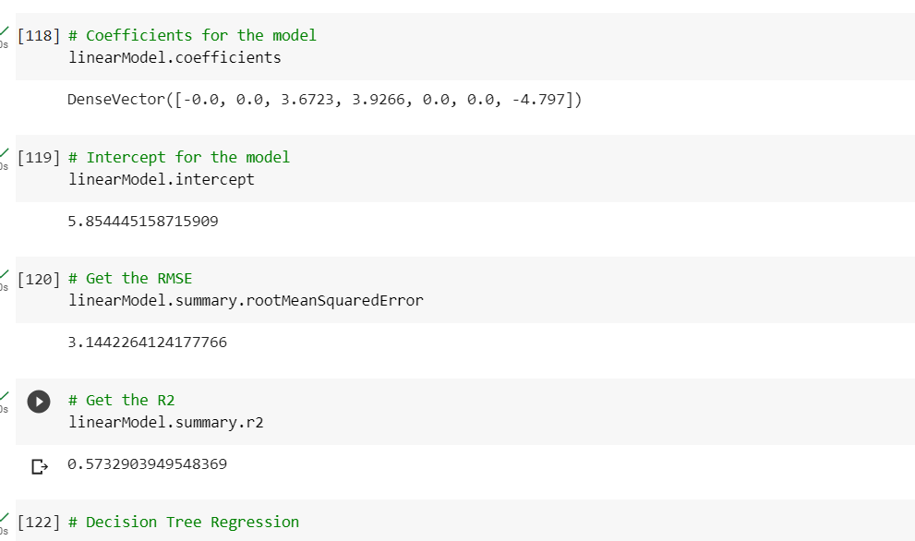

**CONCLUSION**

Decision Tree has given us better result which is just marginally better than Linear Regression.

However the r2 score is better in case of Decision Tree.

Hence, Decision Tree can be used to predict selling price of used car.

Submitted By.:

Abhishek Lal